**CS 262 – Database Management Systems Lab**

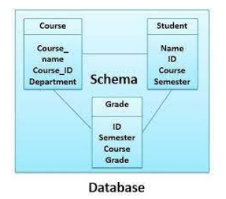

1. **Create the tables in the database.**

**Query:**

create table Course( Course_Name varchar(20),

Course_ID number,

Department varchar(20));

create table Student( Name varchar(30),

Student_ID varchar(10),

Course varchar(20),

Semester varchar(10));

create table Grade( ID varchar(10),

Semester varchar(10),

Course varchar(20),

Grade number);

1. Alter the course table by adding a new attribute instructor.

**Query:**

alter table Course add instructor varchar(20);

1. Alter the student table by modifying the datatype of Student_ID.

**Query:**

alter table Student add instructor number;

alter table Student modify instructor varchar(20);

1. Alter the course table by dropping instructor attribute.

**Query:**

alter table Course drop column instructor;

1. Show the structure of the grade table.

**Query:**

select * from Grade;

1. Load the database with data using insert statements.
2. Retrieve the contents of a table using select statements.
3. Modify the contents of tables using update statements.
4. Delete selected records from the tables.
5. Truncate a table.
6. Drop a table.
7. Commit the changes made to the database.